Our group is interested in the concept of gentrification.
Gentrification is a concept that first came into being in the 1960s (ucl sociologiest). It was used to describe a process where traditionally working class quarters in inner city areas are taken over by members of the middle class. Shabby or run-down accommodation is renovated to create more elegant residences. The concept initially focused on residential transition, but a number of other cultural factors are observed with this change, and now we talk about gentrification as a concept linked to broader spatial economic and social restructuring, distinct cultural change. ‘Retail gentrification’ or ‘boutiqufication’ occurs as spaces change to suit consumer tastes, emphasizing individualisation rather than mass consumption. No doubt you are familiar with the ‘hipster’ cafes and you might have heard about the protest at the cereal café in Shoreditch, London.
Our group finds this process of change really interesting and we would like to explore the issue of gentrification through the lens of consumer segregation. This ‘retail gentrification’. Using available data we want to provide a visual story of the spatial distribution of the ‘middle class consumer and identify areas of London that are more or less gentrified.

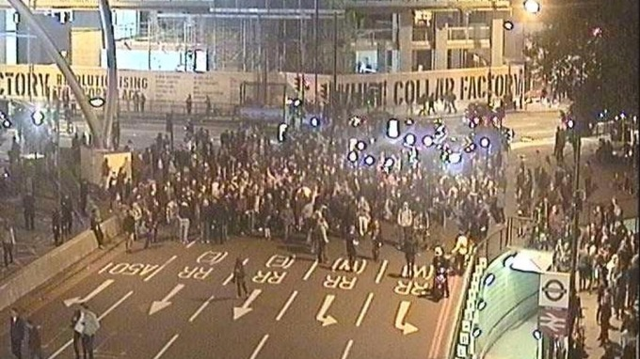


A

  - Describe background to gentrification/cereal café protest/’boutiqification’

